All Saints
Stranton Church
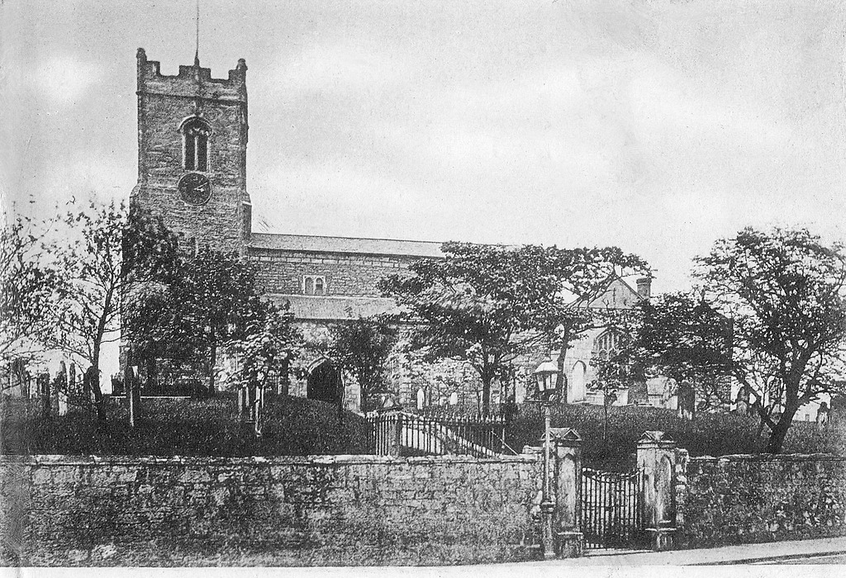
In Tribute of
The Fallen Strantonians
Of the Great War 1914 – 1919
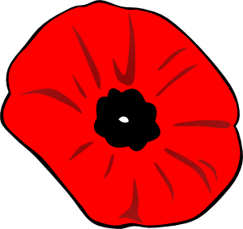
The picture shows Stranton All Saints in the 1890’s one of many memories the Fallen would have taken with them from West Hartlepool
Whilst the fallen are all remembered at Stanton, during this time St.Matthew’s was a church in its own right and this plaque can be found in the current large hall
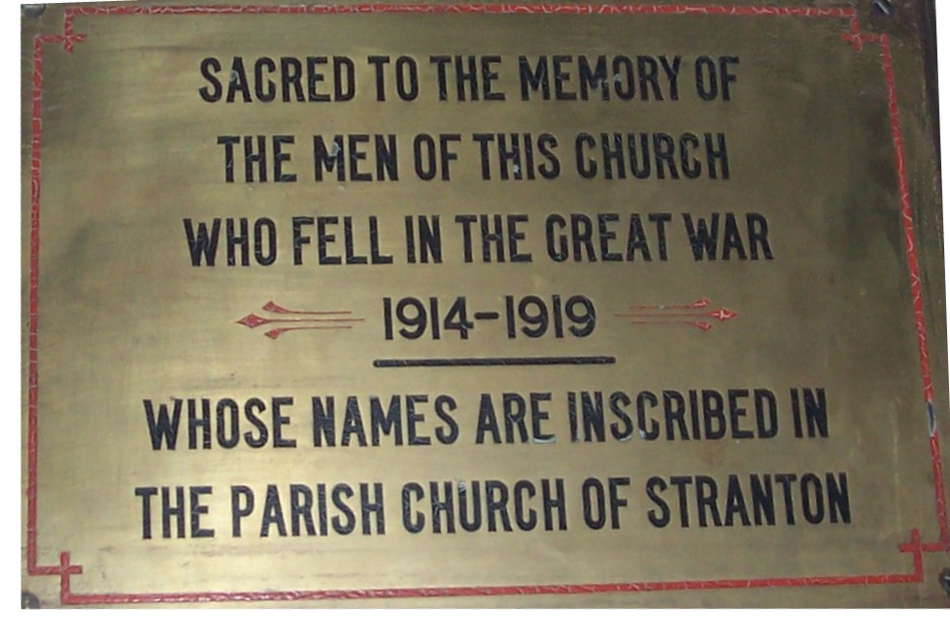

Introduction & Purpose
This book is written first and foremost as a tribute to those who gave their lives in the Great War and where connected to Stranton All Saints West Hartlepool as it was when they lived.
But if it inspires anyone to look further at any individual’s life and service you are more than welcome to use this as a starting point
If you would wish to contact me about any other information about the Fallen of All Saints Stranton
I can be found by email ggeb1956@outlok.com or on 07816445829

George Bainbridge (Author)

The East Window
Which is dedicated to all the Fallen Strantonians

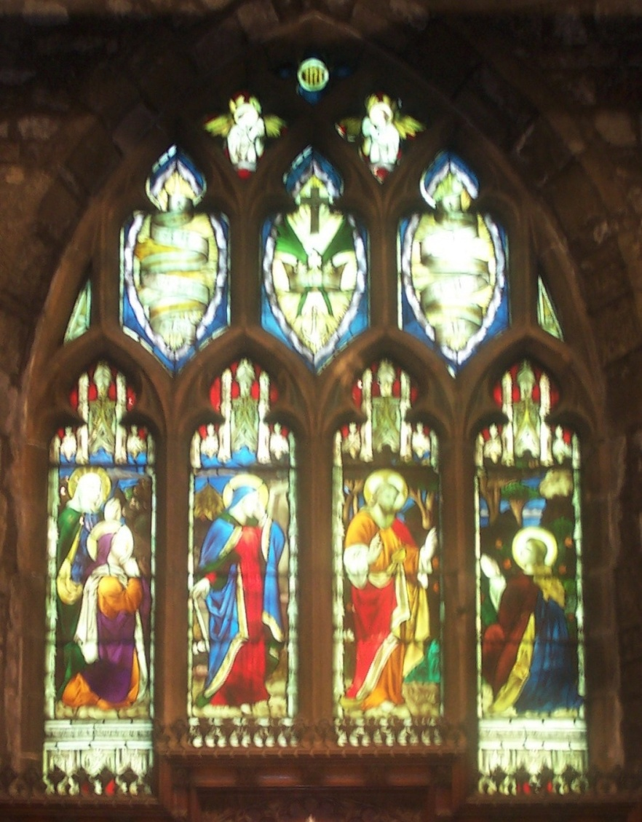

The widow’s dedication is obscured by the wooden decorations

The Medals Strantonians Gained
The 1914 Star
(For those who served from August 1914 – November 1914)
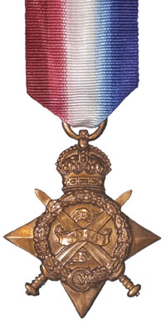
The 1914 – 15 Star
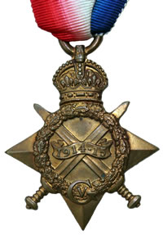
For those who served from August 1914 until December 1915 and were not holders of the 1914 Star
The British War Medal 1914 -1918
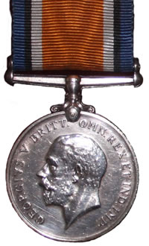
For those who served overseas
The Allied Victory Medal
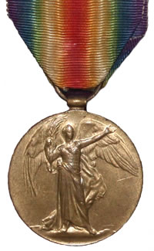
This was awarded to all the allied forces and was identical in each country
The Mercantile Marine Medal
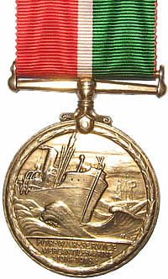
This was awarded to all the Merchant Navy who had sailed through a war zone
between 1914 – 1918
A service man could gain up to three medals
A star, war and victory medal were know as pip, squeak and Wilfred
(After cartoon characters’ from the Daily Mirror)
The Victory & War medals were known as Mutt & Jeff

A Memorial from the King
Each family would receive a Scroll from the King George V and a memorial Plaque (nicknamed the Death Penny)
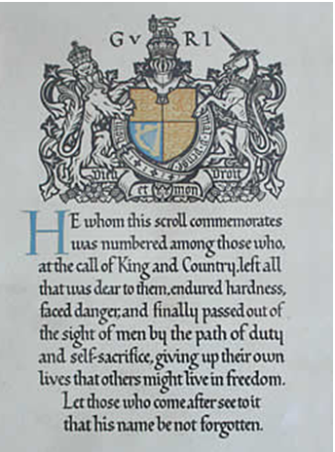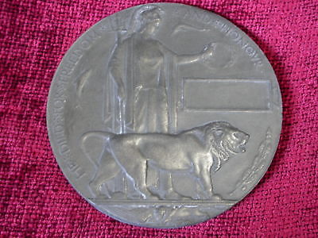

The First of the Fallen
In 1915 the Durham light infantry took part in the second battle of Ypres which began in April
Lance Corporal Robert Henry Robson was the first Strantonian to fall on May 4th 1915.
The Last to Fall during Hostilities
In 1918 was Gunner Thomas William Summersgill of the Royal Garrison Artillery on 17th October 1918 and is buried in the Roisel Communal cemetery which is in the Somme sector
His Final Duty Done
The last Strantonian to die was Private John Richard Thompson who died of wounds on the
14th January 1919

Strantonians at Sea
Not a Happy New Year
One Strantonian, Carpenter Frederick Charles McCarthy was sadly involved in Britain’s worse sea disaster since the loss of the Titanic
On the 1st January 1919 HM Yacht lolaire was packed with returning troops from France when it ran on to rocks known as the Beast of Holm
205 men died even though they were just a short distance from the shore, sadly Frederick was a casualty
It is interesting to note that the official Naval Inquiry did not find any evidence that drink was a factor in the disaster
The Bell of HM Yacht Lolaire
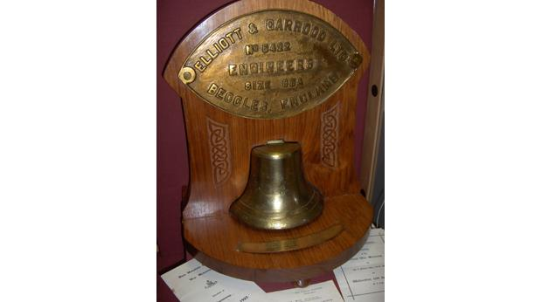

HM Yacht Lolaire
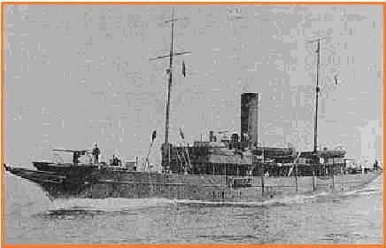

The Youngest Loss
The youngest Strantonian who was lost was an apprentice Merchant Seaman Robert Corbett who served on the ship SS Marmion which was built in West Hartlepool in 1912, it was sank by U Boat 93 on the 26th August 1917 she was on route from New York to Bordeaux
SS Marmion
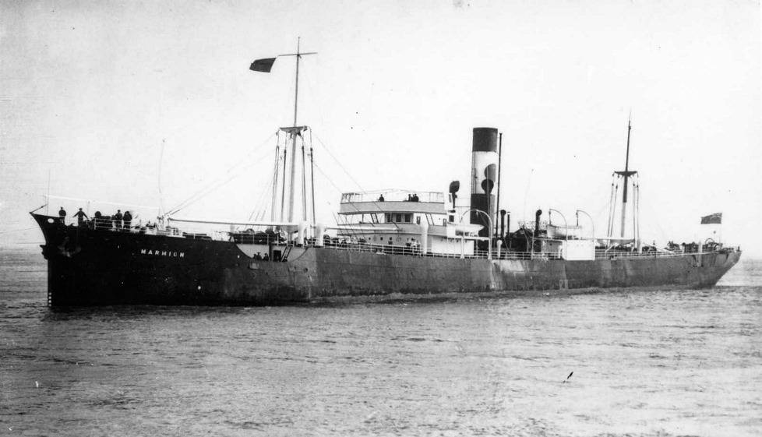
Robert is remembered with his fellow Merchant Navy Comrades at the Tower Hill Memorial in London
HMS Lion
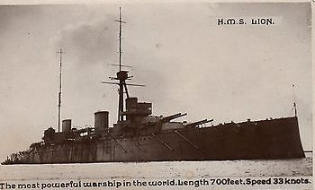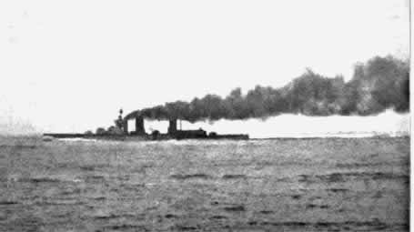
Took part in the Battle of Jutland in 1916 May 31/June 1st Stoker William Muir died from wounds two days after the battle

SS Stanhope (Built in Middlesbrough)
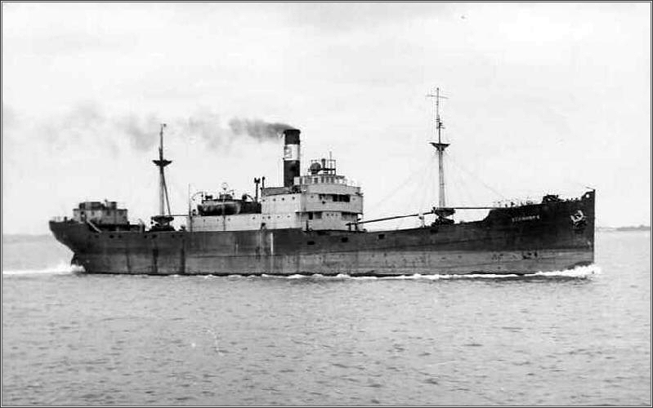
The SS Stanhope which was torpedoed by German Submarine UB 31 on 17th June 1917
Whilst on route from Barrow to Dunkirk Strantonian 2nd Engineer Arthur Morrell
Was drowned his name is recorded on the Tower Hill Memorial, London
Tower Hill Memorial
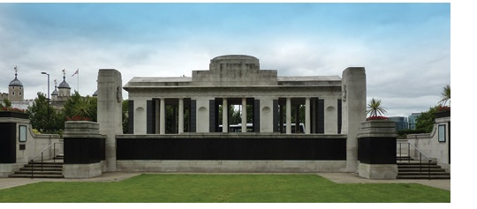
Death in the Mediterranean but a mystery date?
Private Frank Coutlas of the Royal Army Service Corps served on the SS Cameronian which was sunk on 2nd June 1917- some evidence suggest that Frank may have been lost at Sea as the CWGC web site has his death dated as 15 Apr 1917 just under two months prior to the sinking He is remembered on the Chatby memorial at Alexandria
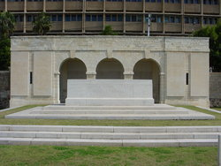

Thiepval Memorial
Several Strantonians are mentioned on the Thiepval Memorial
This was built for the missing of the Somme
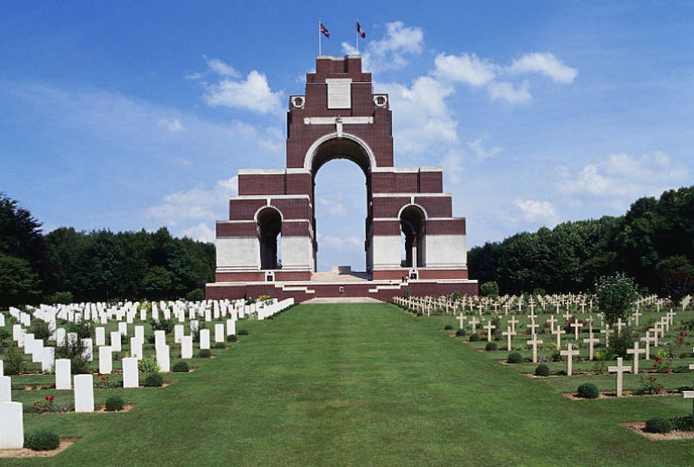
They are Brothers in arms - Privates William & Albert Swinden both served in the Durham Light infantry and both died in September 1916.
2nd Lieutenant Reginald Bennett –the son of Stranton Vicar the Rev Joseph Bennet
William Vincent Pike – who died on July 1st along with 20.000 others on the first day of the battle
Menin Gate
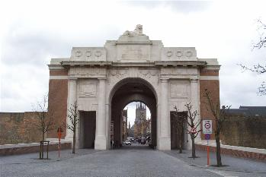
The British Army also fought in Belgium and two Strantonians are named on the Menin Road Memorial at Ypres which is dedicated to the missing
They are George Fordham and John Kneebon Morris
Other missing Strantonians are mentioned on the Tyne Cot, Arras, Vis- En –Artois, Cambrai, Vimy Chatby (Egypt),Polgiester T and Soissons Memorials

Invalided Out –David Nelson of 118 Alma Street lost part of his Left wrist due to wound in his left wrist on 14th October 1915, David only enlisted on the 24th March 1915 he was discharged on 17th February 1916 He died in on 12th July 1918
Occupations- The Strantonians who served in World War One had many varied occupations they include a School Teacher, Carpenter and apprentice, a bobbin carrier, general labourers, docker, postman, butcher’s assistant and errand Boy, wagon shop labourer, clerk, grocer shop assistant ,commercial clerk Yeast Assistant(brewery worker, plumber, machinist. plasterer, timber agent, house painter ,baker and miner
WW1 & Boer War Brothers
Anthony and Elizabeth Mary Robson’s family also suffered in the Boer War when their son
Sgt John Ernest Robson was killed in action on October 1st 1900, their son Lance Corporal Robert Henry Robson died in France 1915 (See addendum)
A tribute to both brothers can be found in the Fulthorpe Chapel.
From Stranton Mission to St.Matthew’s
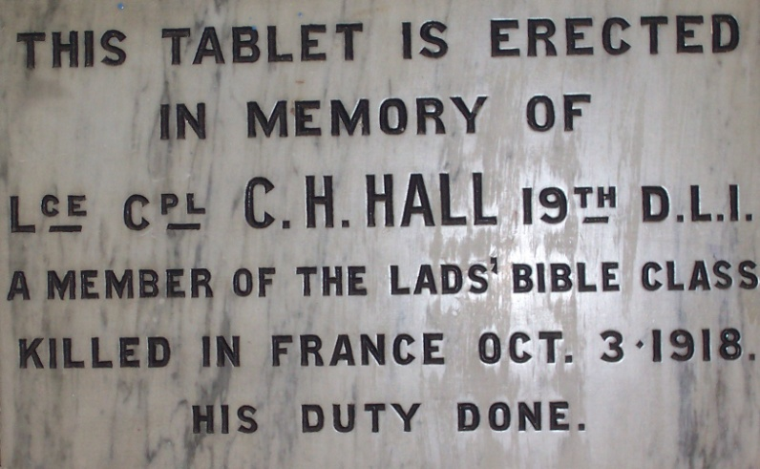
From Stranton Mission, Burbank street to St.Matthew’s Community Centre, Charles Henry Hall was a member of the Lads Bible Class at Stranton Mission in Burbank Street and a tablet was erected there which was then moved to St.Matthew’s hall in the 1980’s and can now be found in the Jim Thompson Room
Although Charles is recorded as an L/Cpl on the tablet according to the CWGC web site he died a private soldier, so this tends to indicate that his promotion must have come very near to the date of his death.

Individual Window Dedications
The Window below is dedicated to
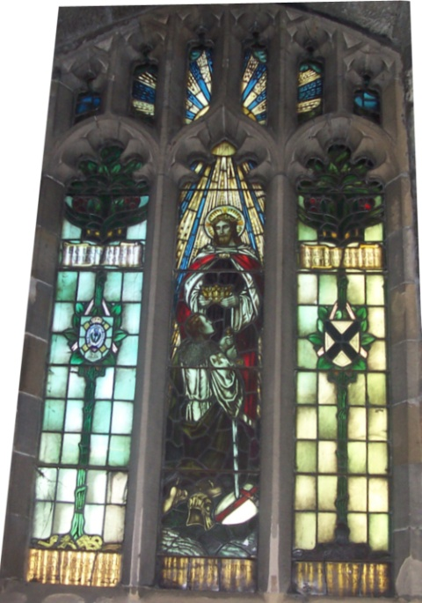
Queen’s Cameron Highlanders 2nd Lieutenant Donald Ord Ross was killed in the battle of Arras 1917 and has window dedicated to him in Stranton, he left the sum of £270 and 9 shillings in his will.
2nd Lieutenant Reginald Bennet has a window dedicated to him in the Fulthorpe Chapel
The Bennet Window
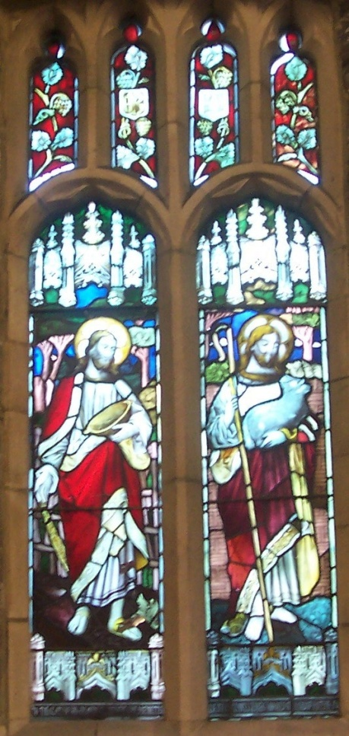
Highest Ranked Strantonian
The Lieutenant Basil Withy took part in the Battle of Albert in 1916 a section of the Somme offensive and died on 2nd July 1916 he left the sum of £5049 15shillings 1d after probate
Another Sad New Years Day
Lance Corporal Wilfred English also served in the same regiment as and survived the war only to die on New Year’s Day 1919
Stranton’s only Flier
Royal Flying Corps – In WW1 Flyers had a very short life expectancy (In 1917 it down to 21 days) which suggests that the training period for the Flying Corp was too short.
Strantonian 2nd Lieutenant Arthur Morgan served with the Royal Flying Corps he is buried in Stranton cemetery
The Oldest Lost
Private Charles Robson was 45 when he was killed during the advance into Flanders, Belgium
Charles left a wife and three children
Dominion Soldier
John William Corbett fought in the Canadian infantry and was killed in the battle of the Somme on
The 26th September 1916 he is remembered on the Vimy Memorial, his parents were
Daniel and Elizabeth Corbett who were from West Hartlepool

The Webster Brothers, their Great War and their Bell Ringing Legacy
The Webster brothers William Branfoot and Robert both served in the Great WarUnfortunately on 5th June 1918 William was killed and is buried in Marfaux British Cemetery, France
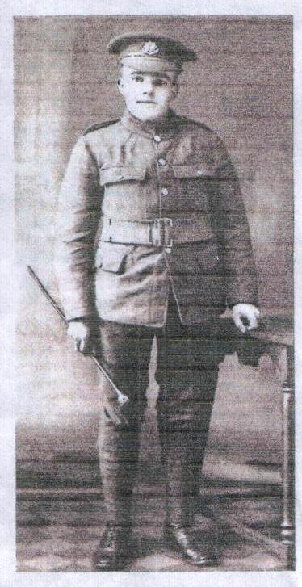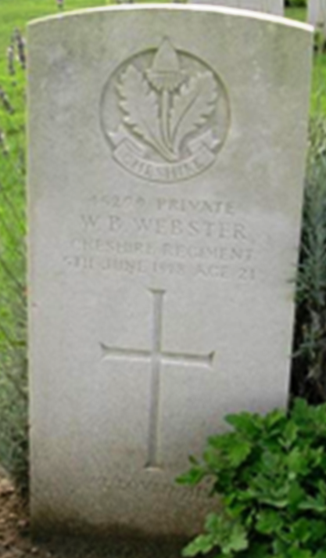
Robert was a Hartlepool volunteer in 1914
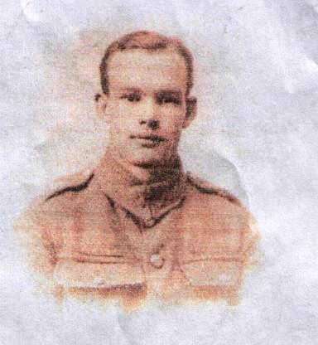
He served in the 18th Battalion of the Durham Light infantry initially he was part of a force that protected the Suez Canal and then was transferred to the Western Front in France
In October 1917 he suffered from head injuries and was placed in a heap of dead soldiers. The next day he recovered consciousness and dragged himself to a first aid post, he was later wounded again.
He survived the War, and became the father of David and Geoff Webster. Robert was a very keen Bell Ringer and taught another Stranton Stalwart Billy Maughan to ring the Bells and in turn Billy taught our present Tower Captain Barbara Busby, so Robert’s legacy to Stranton can still be heard today.
Regiments the Strantonians Served In
King's (Liverpool Regiment) – Two Men | Royal Engineers – Two Men
Royal Flying Corps | Durham Light Infantry Thirteen Men
The Gloucestershire’s– Two Men | East Yorkshire
Queen’s Cameron Highlanders | Royal Garrison Artillery– Two Men
Rifle Brigade | King's Royal Rifle Corps
Northumberland Fusiliers’ | Sherwood Forrester’s (Notts & Derby)
Machine Gun Corps | Royal London Fusiliers
Alexandra, Princess of Wales's Own (Yorkshire Regiment) | King's Own Scottish Borderers
Canadian Infantry | Royal Army Medical Corps
Army Service Corps | Duke of Wellington's (West Riding Regiment)
Wiltshire Regiment | The Loyal North Lancashire Regiment
Royal fusiliers (London regiment) | East Lancashire Regiment
Manchester Regiment | Scots Guards
Royal Scots | West Yorkshire Regiment (Prince of Wales's Own)
Cheshire Regiment

Strantonians also served in the Royal Navy, Royal Naval Reserve and as Mercantile Marines- two men

Where they lived
Locally
Many of the fallen came from homes across the parish, and the table below show names that are recognisable today in 2014 and also which place names that have passed into history
Street | Roads | Other local Place Names
Cornwall | Elwick | Church Row
Wesley | York | Stranton Green
Burbank | Blakelock | Brantford Cottage  West Hartlepool
Bailey |  | Catcote
Benson |  | BURNSIDE," MONTALBO TERRACE
Alderson |  | Stranton Vicarage
Catherine |  | Wansbeck Gardens
Lister
Baden
Bower
Penrhyn
Colenso
Alderson
Perth
Charlotte
Lawrence
Grasmere
Ellison
Jackson
Musgrave
Waldon
Eden
Northumberland
Kilwick

Connected to Stranton but from further afield
Uppingham Rutland, (A military barrack), Sheffield and Driffield Yorkshire

The Story of the Plaque of Remembrance
In the parish magazine of November 1920 published a list of names to be inscribed on a brass tablet and appealed for people to check the accuracy and that the list was complete.
Inside the laurel wreath is pro deo et patria Latin for God and Country
The plaque was unveiled on 24th October 1921** by Rev Archdeacon Derry M.A.
**date not totally confirmed
One anomaly the plaque has William Vincent Pike listed as W.W. Pike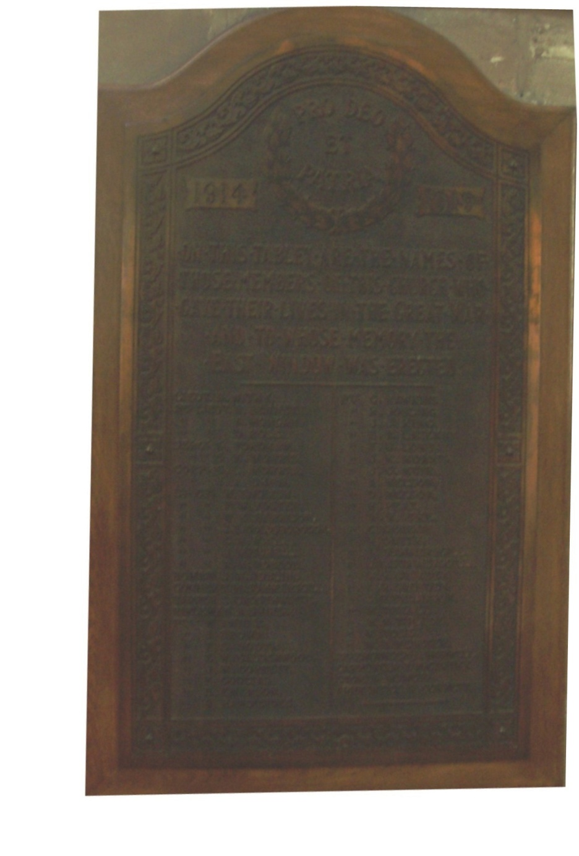
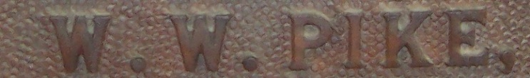

The Fallen
In England
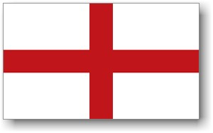
In Hartlepool
2nd Lieutenant Arthur Morgan (Stranton Cemetery)
Private William Tindall (Stranton Cemetery)
In London
2nd Engineer Arthur Morrell
Apprentice Robert Corbett
In Plymouth
Carpenter Fred Charles McCarthy
In Scotland
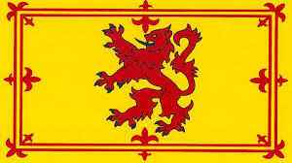
Stoker William Muir

In Germany
Private John Richard Thompson
Lance Corporal Wilfred English
In Egypt

Private Frank Coultas
In Belgium
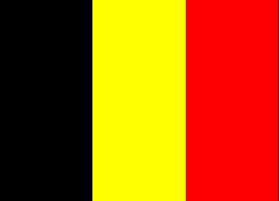
Sergeant George Fordham
Corporal George Lewis Morris
Lance Corporal Percy William Foster
Lance Corporal William Ernest Harrison
Pioneer John Edward Goldsborough
Lance Corporal Charles Henry Hall
Lance Corporal Robert Henry Robson
Acting Bombardier Joseph William Jobling
Rifleman Arthur Shires
Private Stanley Emerson
Private John James King
Private John Kneebon Morris
Private William Vincent Pike
Private Charles Robson
Private Albert Summersgill
Private Mark Tose

In France

Lieutenant Basil Withy 2nd Lieutenant Reginald Bennet 2nd Lieutenant Donald Ord Ross
Sergeant Sidney Kneebon Morris
Corporal Albert Shaw
Lance Corporal John Mitchell
Gunner Thomas William Summersgill
Sapper Sydney Crosthwaite
Private Billy (W) Anniss
Private Jacob Brown
Private Frederick Stephen Booth
Private Edwin Harold Calderwood
Private R (Bertie) Handisides
Private Cecil Stephen Hawkins
Private John William Corbett
Private Harold Jobling
Private Ernest Ransom Lazenby
Private Thomas Benjamin Lowe
Private John George Muir
Private Andrew Nelson
Private Harry Peat
Private Harold Melville Smith
Private John Fall Summersgill
Private William Henry Swinden
Private Albert Edward Swinden
Private William Branford Webster

Addendum
The Boer War Memorial at Ward Jackson Park, Hartlepool
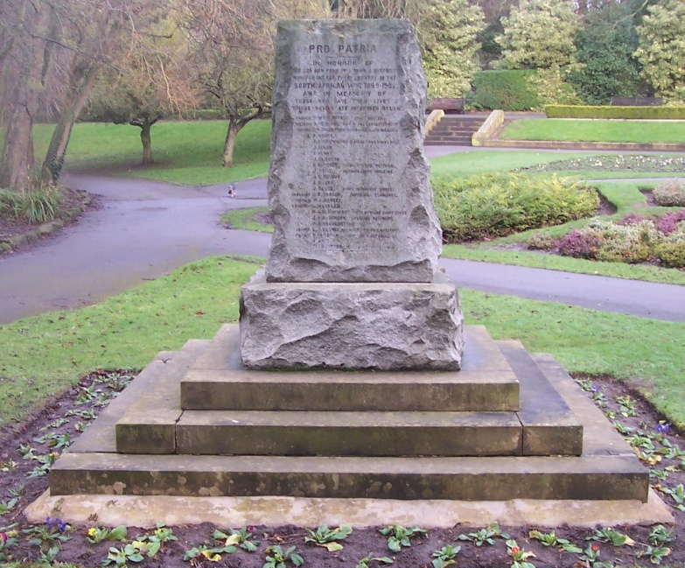
Where Sgt John Ernest Robson is remembered
The Robson’s Memorial (Found in the Fulthorpe Chapel)
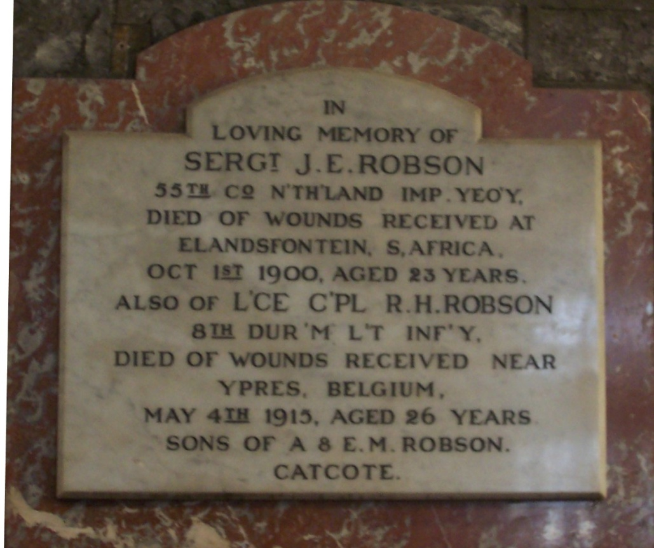
The Cross of Sacrifice
(Found at every War Grave Cemetery & Memorial)
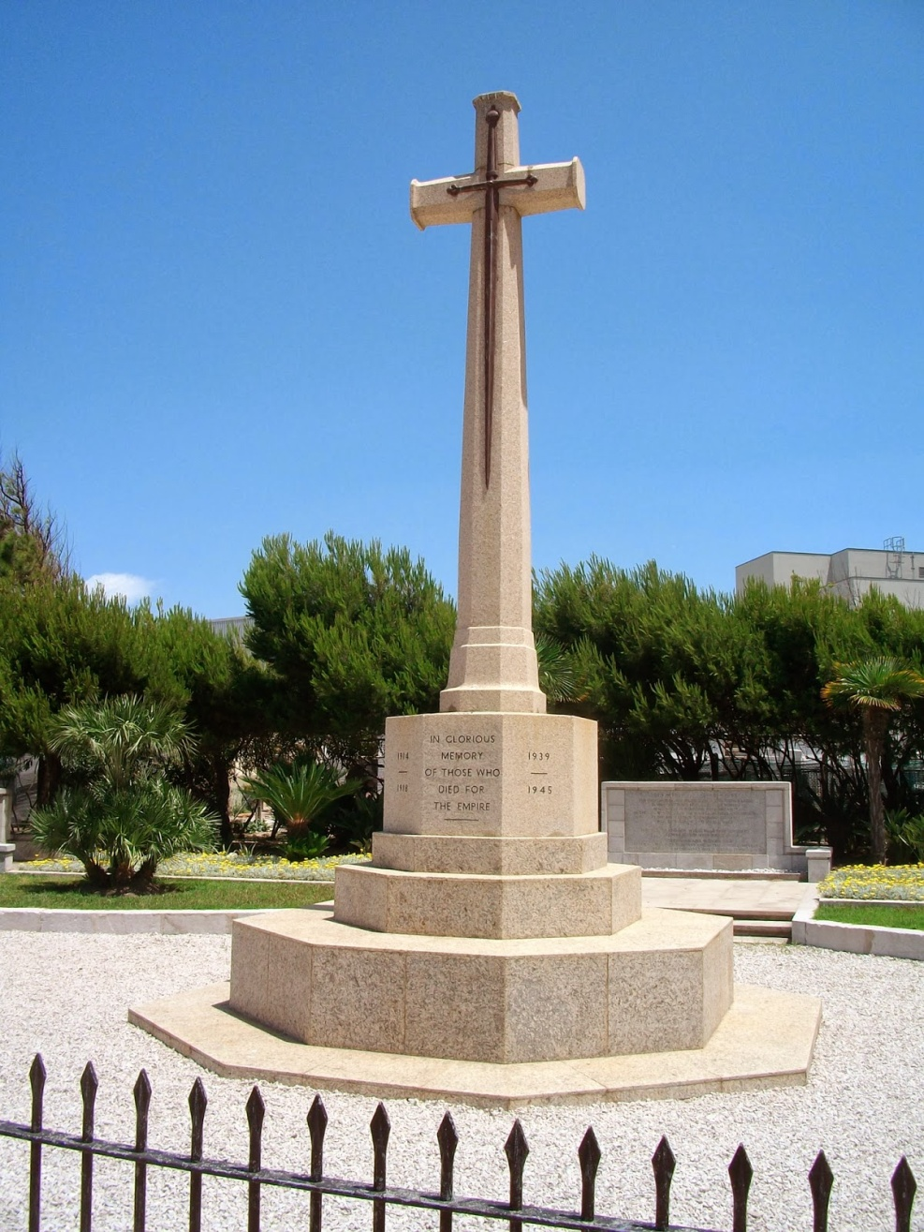

They shall grow not old, as we that are left grow old.
Age shall not weary them, nor the years condemn.
At the going down of the sun and in the morning
We will remember them".
Taken from the Fallen by Laurence Binyon

Target June 2014

